Chapter 1:

- INTRODUCTION:

People are now treating fitness as their priority over many things. With the growth of the internet, education about fitness is spreading at good rate. People are now understanding the importance of fitness in life, resulting the increasing number of websites related to health and fitness. Many people who are in fitness field or interested in fitness, mostly beginners are looking for sites which can help them learn workouts, nutrition, fitness. Many websites help them in this but mostly they have to struggle to use those. Websites specifically focus on particular topics. Some are just for the calculations or nutrition. Few of them only focus on workouts. So, people are always changing the sites for their needs.

The idea is to create a website which can cover all the topics from fitness like workouts, yoga, cardio, fitness tools, muscle and body information, nutrition, etc. to Health like hormonal changes, diabetes, body care, etc. So that people will find everything they need at same place. People can learn about Workouts, diets, health at same place and implement in their life. Physical fitness is considered as a measure of the body's ability to function efficiently and effectively during work and leisure activities.

In order to remain physically fit and healthy, we need to engage ourselves in physical activities and take measures for physically fit. Health and fitness are the most important aspect of our life. There is nothing more important than health for any human being. When we are healthy and fit, we are able to enjoy our life well. So, on our site there are suggestion and all the physical activities and Exercise one should perform as per his/her body requirement. Now a days People doesn`t have that much time to go physically to the GYM or Yoga Classes for Exercise so the standard and Modern way is to give all the information on the smart-phones and utilize their busy schedule. On our website we will provide the utmost best knowledge and suggestion about the particular gained information.

Providing every individual person their wealth information and goods and bad aspects,
What the person should do and what not to do. Making their lifestyle easy and comfortable and the main issue of physical displacement get reduced. A one can practice every exercise from the respective Residence.

MOTIVATION:

This project was suggested by our guide Prof S. S. Mete mam. The use of Internet is a major source of advice and information for health has been increasing with the time. According to a recent report on the Internet there are 7000 fitness related websites available. There may be a number of reasons why the people search online for health and fitness information. As the number of people consulting the Internet for Fitness advice increases, issues related to the usage and trust come to the front. A range of information and a large number of sites available offer more choices to health and maintain fitness of the consumers. The problem confronting the study is the design of “Healthcare Online Fitness Guider”.

OBJECTIVES:

Main objective is to provide good interactive & communication facilities to the Customer accessing our site for the suggestions and advices.
Customer should be fully agreeing by our site, and should be effective for his/her required certain fitness related issues.

ISSUES FOR CONCENDRATIONS:

The use of Internet is a major source of advice and information for health has been increasing with the time. According to a recent report on the Internet there are 7000 fitness related websites available. There may be a number of reasons why the people search online for health and fitness information. As the number of people consulting the Internet for Fitness advice increases, issues related to the usage and trust come to the front. A range of information and a large number of sites available offer more choices to health and maintain fitness of the consumers. The problem confronting the study is the design of “Healthcare Online Fitness Guider”.

CHAPTER 2

Literature Survey:

Before building this project there are many sites that are already made on fitness, exercise, yoga, and other exercises ways. Here are some sites which will show How the Fitness Trainer Site actually works and perform their task including their Main focus.

- Glo
Glo is one of the most highly regarded online yoga platforms. Here you have the chance to practice with some of the world’s leading yoga teachers, right from your living room. Whether you are looking for a 5-minute meditation, a 20-minute practice you can do upon waking, or a fully guided yoga teacher training module- Glo spans the entire breadth of the yoga journey and caters to every level of practitioner and their unique goals. Glo offers a real, supportive, warm space for you to explore yoga on your own terms.

Main focus:

- Online available trainers.
- Has some time slot when the trainer and student.
- They had more focus on normal yoga poses and good for all ages.
- This website is very good for regular practice.

Website:
https://www.glo.com

- HelathifyMe:
In May 2015, the company launched a campaign, HealthifyIndia, in collaboration with Godrej Nature's Basket, Manipal Hospitals, Medanta and Apollo Centre, to promote healthy living amongst Indians and create awareness of lifestyle disorders. It was reported that HelathifyMe's website had become the most visited health website in India, with 40 lakh visitors.
Main Focus:
- Services such as calorie tracking.
- Advice on nutrition and fitness.
- Gives the Proper locality suitable climate.
- Shows the Activity status of a particular candidate.

Website:
https://www.healthifyMe.com

- Daily Burn:
Daily Burn is one of the most popular online fitness platforms that offers over 1000 different types of workouts to suit all levels. From Pilates to Yoga, Mobility, HIIT, and Weightlifting you can log in from anywhere and get moving. If you need a little more guidance, you can answer some questions around your fitness goals and the platform will create a fitness plan for you- just like your own personal trainer! Memberships are only $13 a month and all classes are offered by certified trainers that have years of experience getting results. Despite its vast breadth and popularity, Daily Burn is tailored to your needs and based on your goals and fitness level.

Main Focus:
- This site has Various Yoga types.
- Focus maximum on Pilates practice and muscles workout.
- Has their own database.
- This site is paid, as per the Requirement.
- Online Certificate by Certified Trainer.

Website:
http://dailyburn.com/landing

Overviews:
According to all the information given below every site performs their level hard to Suggest and help the Customer in all the Aspects like
Suggesting proper yoga and exercise
Providing them calories burn information
Showing them their Overweight, Lose Weight
Advising them about Nutrients and Nitrous Diet, is all the mandatory policies each site should provide.

In our website we are trying to put this entire essential content people needed.
Like : 1.Proper Exercise
2.Healty Diet
3.Diet Plan
4.Their Daily Activities

We are Building a Project in which the user would login in to our Site , fill the information like Name , Gender , Age ,Wight , Height according to that the BMI will calculate about the Person's Personality . And will suggest whether the Person is over weight or not .
We would have Three Categories of Exercise depending on the Person Requirements
1. Normal Exercise ( Daily Life Exercise )
We would suggest all the Daily exercise a person should perform to be fit and Healthy . Would also have the Daily Remainders over the Exercise and Diet .
2. Weight Loss or Weight Gain
After calculating the weight, age as per the gender and height, the BMI calculator will suggest the user about the exercise as per the weight gain and weight loss . This will keep the track on the activities of the user and will show him / her their daily Progress .
3. Disease related Exercise
This category is for the people who are suffering from some illness, health issue, and are looking for some sitting exercise ,yoga and relaxation exercise , which will make their disease not affecting their Normal lives .

Last but not Least we will provide every individual their activities , time-table , and the Cirtificate of Their Workout after the completion of their respective tasks .
Being more Friendly to them by GUI base interaction makes our communication and relation strong and will attract people to use our site.
Doing Literature Survey has made our concept clearer about what to do and what not to do.
Keeping this in mind we would construct the Project.

CHAPTER 3

- Aim:
The main aim of the project is to design and develop a user-friendly website which facilitate fitness centre to automate its operation of storing the details of the members, employees, services and transaction occur in the fitness centre.

- Objectives
The objectives of this study are summarized below:

- The main objective of the project is to design and develop a user-friendly efficient Fitness Trainer Website.
- An accurate system without any data redundancy.
- Secured data storage for Authority end.
- Secure the user ends data by providing each user’s own personal credentials.
- A flexible system which can manage the customer-staff relationship in an effective manner.
- To provide better graphical user interface.

- Action Plan
Sr no. | Detail of Activity | Plan start date | Plan Finish Date | Name of student
1 | We Search on the Topic | 05/09/2022 | 11/09/2022 | Prerana Chavhan  Vijay Shinde  Shubham Chirde  Hrutuja Umratkar  Ravina Khadtare
2 | To identify its problem & its need/solution | 14/09/2022 | 20/09/2022 | Prerana Chavhan  Vijay Shinde  Shubham Chirde  Hrutuja Umratkar  Ravina Khadtare
3 | Collect more information about our project | 21/09/2022 | 03/10/2022 | Prerana Chavhan  Vijay Shinde  Shubham Chirde  Hrutuja Umratkar  Ravina Khadtare
4 | Looking for the Programming language and Database | 04/10/2022 | 14/10/2022 | Prerana Chavhan  Vijay Shinde  Shubham Chirde  Hrutuja Umratkar  Ravina Khadtare
5 | Add propose module to report | 17/10/2022 | 28/10/2022 | Prerana Chavhan  Vijay Shinde  Shubham Chirde  Hrutuja Umratkar  Ravina Khadtare
6 | Some Difficulties solved by respective Guide | 31/10/2022 | 19/11/2022 | Prerana Chavhan  Vijay Shinde  Shubham Chirde  Hrutuja Umratkar  Ravina Khadtare
7 | Further information required for the formation of Project | 10/12/2022 | 15/12/2022 | Prerana Chavhan  Vijay Shinde  Shubham Chirde  Hrutuja Umratkar  Ravina Khadtare

- Proposed Methodology:

The Purpose or objective of website is to create an automated system.
The system will perform the task like taking input from the user about his/her body, asking for their weight, height, gender, age and all the human essential information. The present scenario in the gyms or yoga classes is that people are avoiding going out of the house for this Purpose. But maintaining our Health and be fit is the best practice one could do for making their life style free from diseases and other disorders. Physical, emotional, mental stress can be cured by the proper Habitats. In this busy world people now, days are not aware about the good hygiene proper Diet. So, on our site on the basis of the person gesture we will suggest them a certain diet that he/she should take for their better fitness.

Our website is mainly based on giving the individual suggestions and making their daily routine, daily timetable, daily goals, daily activities store their information, providing them the proper path towards healthy lifestyle. We are going to work on the BMI for calculating the mass of the individual, calculating their activities is done using the programming and coding.
The user would ask for their interest, their liking for doing which type of Exercise they wished to do. The user will work as per the duration of the course, after the completion of the particular task, at end the user will get the certificate for completion of the course and all this information is store on the Data-base.

In our Project we have planned to implement whole project through Java and the Database through Oracle.
We wish to achieve our Target and would make a successful fitness site.

- References and Bibliography:

We have take the use of many sites for gathering the information about the Topic, and making aur concept more clear about it.
Some sites are listed below
- https://www.fitlab.nl/
- www.greeksforgreeks.com
- https://www.boombox-boxing.com/
- https://yfitnesslab.com/

Programming languages
- https://getbootstrap.com
- https://w3schools.com
- https://en.m.wikipedia.org

- Conclusion:

By this website people are now able do the exercise and do the Yoga by being in their own Residence. He/ She will get the proper information and guidance for making themselves Fit and Healthy. All the exercise and diet plan are available on the website by which every indivitual will get a proper guidence.

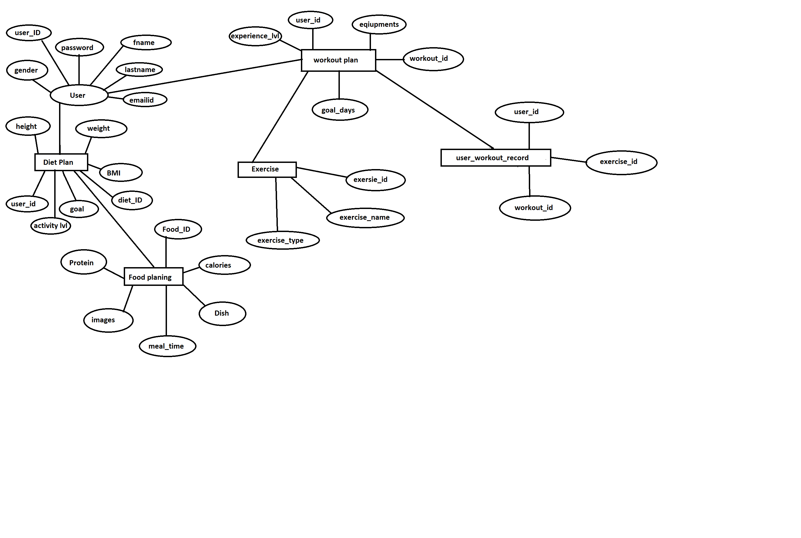
ER DIAGRAM

USE CASE DIAGRAM

Fig 1. Admin

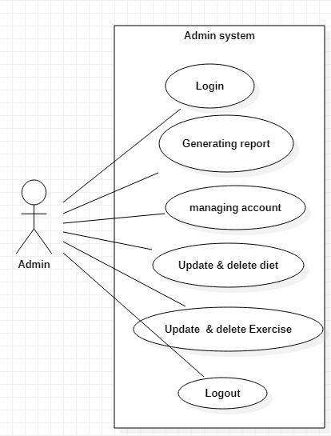

Fig 2. Customer
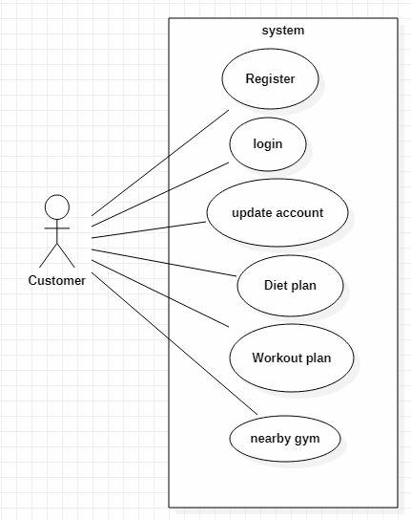
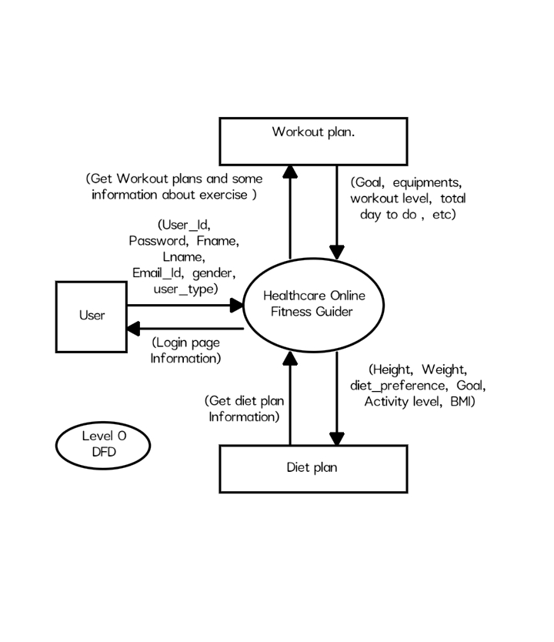
Data Flow Diagram :

